Ulysses S. Grant
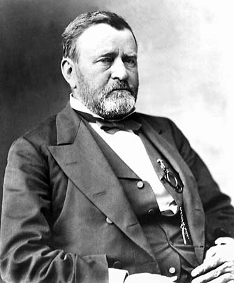
Ulysses Simpson Grant was best remembered for his military leadership during the Civil War and for the corruption that characterized his presidential administration during America's Gilded Age.
Born in Pleasant Point, Ohio on April 27, 1822, Grant attended public school in nearby Georgetown until his father secured an appointment for him to West Point in 1839. Upon graduation in 1843, he was assigned to the infantry. He served two years in Missouri and Louisiana before joining Gen. Zachary Taylor's army in Texas.
Although he felt that the Mexican-American War was unjustly provoked by the United States, Grant fought valiantly, first with Gen. Taylor's army, then with Gen. Winfield Scott's troops on the long march from the port of Veracruz to the capital, Mexico City.
In 1852, Grant was transferred to the western coast of the U.S. territories. He was stationed first at isolated Fort Vancouver and then, after being promoted to captain, at even more remote Humboldt Bay. Lonely, miserable, and unable to obey his commanding officer's warning not to drink to excess, Grant was forced to submit his resignation from the army in 1854.
Grant returned to Illinois and failed at a number of occupations: farmer, real estate agent, candidate for county engineer, and clerk in a customhouse. The Civil War rescued Grant from the oblivion of spending his life as a clerk in his father's general store. He secured an appointment as a colonel in the state militia and then, in August 1861, was promoted to brigadier general. He became a national hero in February 1862 after he led his troops into Tennessee and captured Fort Donelson on the Cumberland River, along with its garrison of approximately 14,000 men.
After almost being defeated at Shiloh, Grant devised and implemented a brilliant campaign to split the Confederacy in half along the Mississippi River. He moved 30,000 men south of Vicksburg, ferried them across the Mississippi River without supplies, and then by separately defeating two Confederate armies before they could unite, finally forced the garrison in Vicksburg to surrender on July 4, 1863 after a six-week siege. After Grant snatched victory from defeat by rescuing a large army at Chattanooga, President Abraham Lincoln chose him to command all the armies of the United States.
As general in chief of the Union forces, Grant provided the leadership necessary to coordinate the superior military and industrial resources of the North against the South. While his numerically superior forces wore down Gen. Robert E. Lee's army, Grant dispatched other generals to attack elsewhere in the South to ensure that Lee could not receive any reinforcements or supplies. Although criticized for the ruthlessness and destructiveness of his tactics, both in terms of human life and in civilian property, the success of his "total war" approach was proven when Lee was forced to surrender at Appomattox Courthouse on April 9, 1865.
After Lincoln's assassination, an unpopular President Andrew Johnson became locked in a furious battle with the ruling majority of Radical Republicans in Congress, who disagreed with Johnson's Reconstruction plan. Grant attempted to avoid entanglement in Johnson's political problems, but this proved impossible. He moved away from Johnson's policy and toward that of congressional Republicans in 1866, before Congress enacted Negro suffrage. The reason was the increasing intransigence and violence of Southern whites, not only against blacks and Republicans but against any Northerners in the South, including the army, of which Grant was general in chief.
The Radicals gained effective control of the party and swept the elections of 1866. They were able to override Johnson's vetoes and make laws curtailing executive powers, including the Tenure of Office Act (1867). This prohibited Johnson from firing a Cabinet officer without the consent of Congress. When Johnson fired Secretary of War Edwin M. Stanton, Grant agreed to act as secretary until a replacement was appointed. However, when the Senate refused to accept the dismissal of Stanton, Grant refused to continue in the office. President Johnson's public accusation that Grant had betrayed him infuriated Grant and drove him into the arms of the Radical Republicans.
While the battle between Johnson and Congress raged, Grant savored the gifts bestowed upon him by a grateful nation. He was given the rank of lieutenant general and named general in chief. In Philadelphia, a group of businessmen gave him a magnificent, fully furnished house. Merchants in New York gave him $100,000. Wealthy businessmen in Washington, refusing to be outdone, gave him another home and $75,000.

